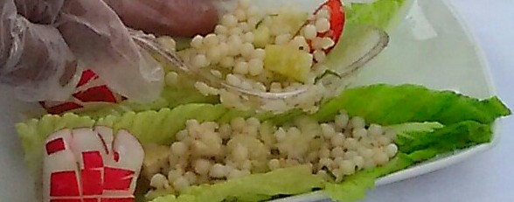

Ingredients:
Israeli Pearl Couscous, Cucumbers Diced, Cherry Tomatoes or Grape Tomatoes Cut in Half, Celery thin sliced, Light Olive Oil
Preparation:
Boil couscous in vegetable Stock, Look for Low sodium if you can’t find low sodium boil in half vegetable stock and water. While couscous drains slice your cucumbers, cherry tomatoes / grape tomatoes and thinly sliced celery. Mix and add olive oil. You can add any of the following to get the flavor you desire. Basil, Parsley, Ginger, Do Not Add Oregano or Rosemary unless you buy it grounded because it is hard and will get stick in your gums and teeth. Drizzle with light olive oil to coat 2-3 Tablespoons depending on amount of couscous

Alternatives
Zesty Chicken Orzo Salad
Prepare as above just add diced or shredded meat such as chicken, turkey, great for leftover meat. Instead of Olive Oil use Wish Bone Light Italian Dressing.

Where to buy: You can find Israeli Couscous at Gristedes Supermarkets, Garden Gourmet Market- 5665 Broadway, Bronx, NY

You can even ask your local supermarkets.

